Reading Spine – Sycamore

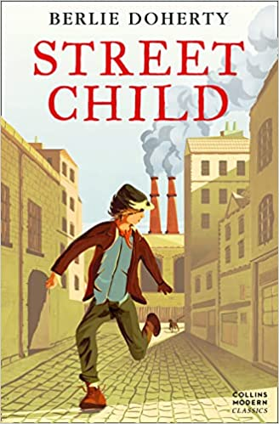 | The Street Child by Berlie Doherty  When his mother dies, Jim Jarvis is left all alone in London. He is sent to the workhouse but quickly escapes, choosing a hard life on the streets of the city over the confines of the workhouse walls.  Struggling to survive, Jim finally finds some friends… only to be snatched away and made to work for the remorselessly cruel Grimy Nick, constantly guarded by his vicious dog, Snipe.  Will Jim ever manage to be free?
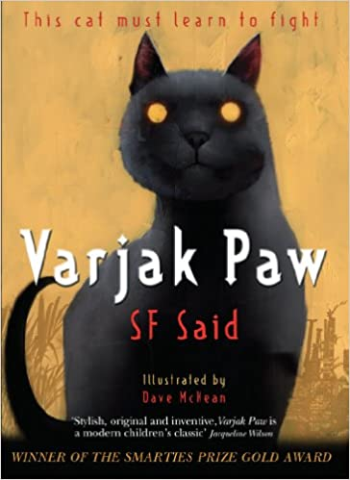 | Varjak Paw by SF Said  This cat must learn to fight!  Varjak Paw is a Mesopotamian Blue kitten. He lives high up in an old house on a hill. He's never left home, but then his grandfather tells him about the Way - a secret martial art for cats.  'There are Seven Skills in the way of Jalal,' whispered the Elder Paw. 'We know only three of them. Their names are these. Slow-Time. Moving Circles. Shadow-walking.'  Now Varjak must use the Way to survive in a city full of dangerous dogs, cat gangs and, strangest of all, the mysterious Vanishings.
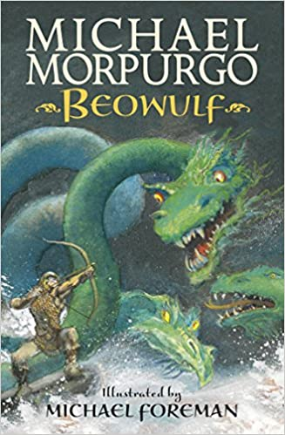 | Beowulf by Michael Morpurgo  "In fifth-century Denmark, a murderous monster stalks the night, and only the great prince of the Geats has the strength and courage to defeat him. Beowulf's terrifying quest to destroy Grendel, the foul fiend, a hideous sea-hag and a monstrous fire-dragon is the oldest surviving epic in British literature. Artfully retold and magnificently illustrated, this companion volume to Sir Gawain and the Green Knight is made instantly accessible to children by a formidable children's book partnership"
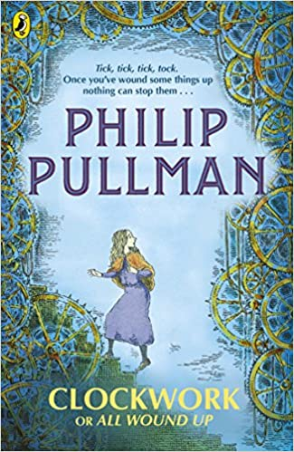 | Clockwork by Philip Pullman  It is a cold winter's night when Karl enters the White Horse Tavern looking like he's swallowed a thundercloud. His final task as a clockmaker apprentice is to make a new figure for the great clock of Glockenheim. He has not made the figure - or got any idea of what it could be, and the unveiling is tomorrow.  Fritz is also in the tavern; there to read aloud his new spooky story. Like Karl, he hasn't finished. Well, he knows how the story starts and he knows it's called Clockwork - so, with the snow swirling down outside, he sets his story going and just has to hope that the ending will come to him as he tells it.  Suddenly, Fritz's story and real life merge in a completely sinister way - and just like clockwork it can't be stopped . . .
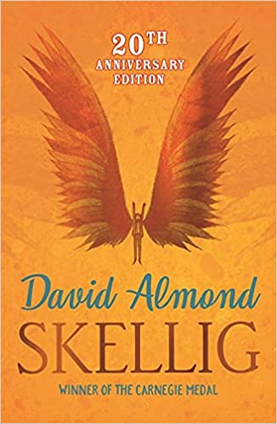 | Skellig by David Almond  When a move to a new house coincides with his baby sister's illness, Michael's world seems suddenly lonely and uncertain.  Then, one Sunday afternoon, he stumbles into the old, ramshackle garage of his new home, and finds something magical. A strange creature - part owl, part angel, a being who needs Michael's help if he is to survive. With his new friend Mina, Michael nourishes Skellig back to health, while his baby sister languishes in the hospital.  But Skellig is far more than he at first appears, and as he helps Michael breathe life into his tiny sister, Michael's world changes for ever . . .
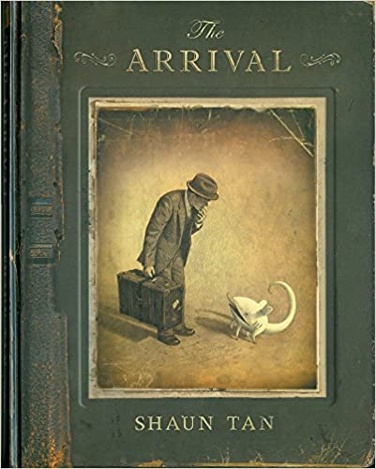 | The Arrival by Shaun Tan  The Arrival is an immigrant story, but in a more universal sense it conveys the feeling that we’ve all had at some point of being lost, frightened or confused in an unfamiliar environment. It reminds us that new beginnings can be scary, and the spirit of patience and hospitality are always a welcome port in a storm.
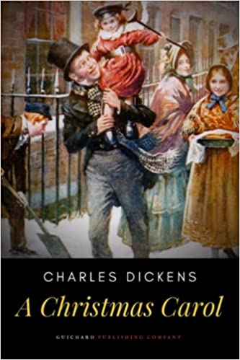 | A Christmas Carol by Charles Dickens  One Christmas Eve, Scrooge is visited by the ghost of his former business partner Jacob Marley and the spirits of Christmas Past, Present and Yet to Come, and given a glimpse of the many homes and lives which Scrooge has touched in his wretched life to date. After their visits, Scrooge is transformed into a kinder, gentler man.
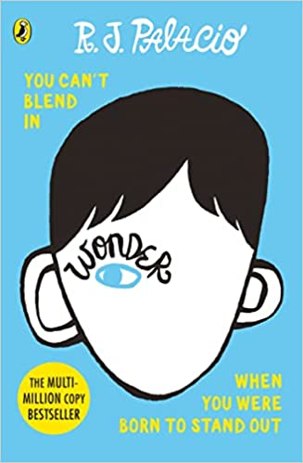 | Wonder by R J Palacio  Auggie wants to be an ordinary ten-year-old. He does ordinary things - eating ice cream, playing on his Xbox. He feels ordinary - inside. But ordinary kids don't make other ordinary kids run away screaming in playgrounds. Ordinary kids aren't stared at wherever they go.  Born with a terrible facial abnormality, Auggie has been home-schooled by his parents his whole life. Now, for the first time, he's being sent to a real school - and he's dreading it. All he wants is to be accepted - but can he convince his new classmates that he's just like them, underneath it all?
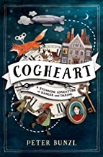 | Cogheart by Peter Bunz  With her friends – Robert, the clockmaker’s son, and Malkin, her mechanical fox – Lily is plunged into a murky and menacing world. Too soon lily realizes that those she holds dear may be the very ones to break her heart….  Murder, mayhem and mystery meet in this gripping Victorian adventure.
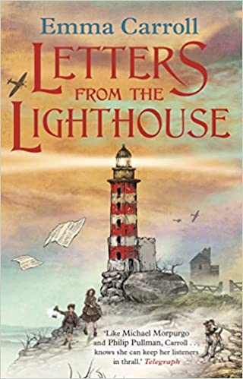 | Letters from the Lighthouse by Emma Carroll  February, 1941. After months of bombing raids in London, twelve-year-old Olive Bradshaw and her little brother Cliff are evacuated to the Devon coast. The only person with two spare beds is Mr Ephraim, the local lighthouse keeper. But he's not used to company and he certainly doesn't want any evacuees.  Desperate to be helpful, Olive becomes his post-girl, carrying secret messages (as she likes to think of the letters) to the villagers. But Olive has a secret of her own. Her older sister Sukie went missing in an air raid, and she's desperate to discover what happened to her. And then she finds a strange coded note which seems to link Sukie to Devon, and to something dark and impossibly dangerous.
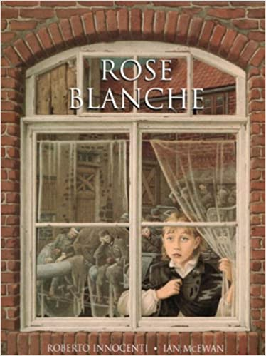 | Rose Blanche by Ian McEwan  Rose Blanche was the name of a group of young German citizens who, at their peril, protested against the war. Like them, Rose observes all the changes going on around her which others choose to ignore. She watches as the streets of her small German town fill with soldiers. One day she sees a little boy escaping from the back of a truck, only to be captured by the mayor and shoved back into it. Rose follows the truck to a desolate place out of town, where she discovers many other children, staring hungrily from behind an electric barbed wire fence. She starts bringing the children food, instinctively sensing the need for secrecy, even with her mother. Until the tide of the war turns and soldiers in different uniforms stream in from the East, and Rose and the imprisoned children disappear for ever . . .
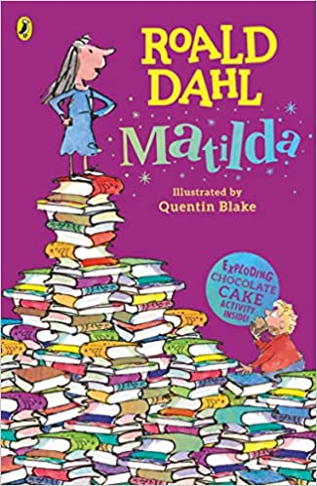 | Matilda by Roald Dahl  Matilda is the world's most famous bookworm, no thanks to her ghastly parents.  Her father thinks she's a little scab. Her mother spends all afternoon playing bingo.  And her headmistress, Miss Trunchbull? She's the worst of all.  She's a big bully, who thinks all her pupils are rotten and locks them in the dreaded Chokey.  Despite these beastly grownups trying to push her down, Matilda is an extraordinary girl with a magical mind. And she’s had enough.  So all the terrible adults had better watch out, because she’s going to teach them a lesson they’ll never forget!
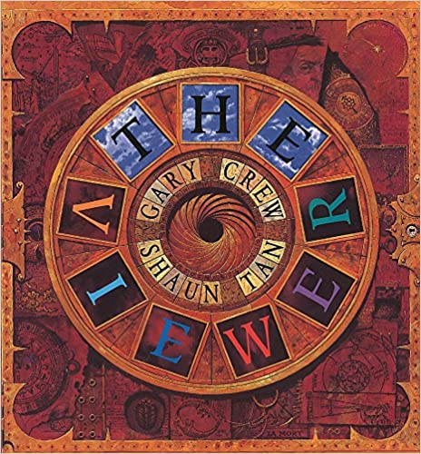 | The Viewer by Gary Crew  Young Tristan, a curious boy who rescues all sorts of objects from the rubbish dump, finds an old Viewmaster in its elaborate box, complete with a set of disks. He finds that these represent the ages of humankind, seen as a cyclical structure in which patterns of growth and decay are repeated.  Tristan becomes more and more drawn in to the world of the disks, and eventually disappears.
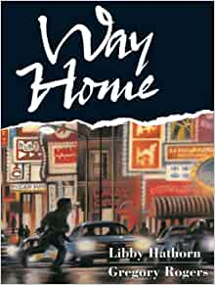 | Way Home by Gregory Rogers  It's night and the dark is filled with strange sounds as Shane makes his way home. On a fence he finds a stray cat that at first growls and spits at him. But Shane talks and strokes the kitten to calmness, and decides to take the 'Spitfire, Kitten Number One,' home with him. No gang of boys, or avenue of dense traffic, or fierce dog can stop Shane carrying his new found friend to the place he calls home. Greg Rogers' sensitive use of charcoal and pastel create Shane and his cat in splendid city-at-night time scenes.
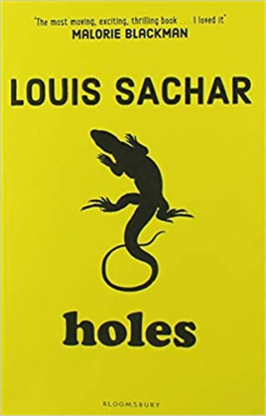 | Holes by Louise Sachar  Stanley Yelnats' family has a history of bad luck, so when a miscarriage of justice sends him to Camp Green Lake Juvenile Detention Centre (which isn't green and doesn't have a lake) he is not surprised. Every day he and the other inmates are told to dig a hole, five foot wide by five foot deep, reporting anything they find. Why? The evil warden claims that it's character building, but this is a lie. It's up to Stanley to dig up the truth.  Witty, inventive and completely unique, this is a masterpiece of storytelling that combines sly humour with irresistible, page-turning writing.
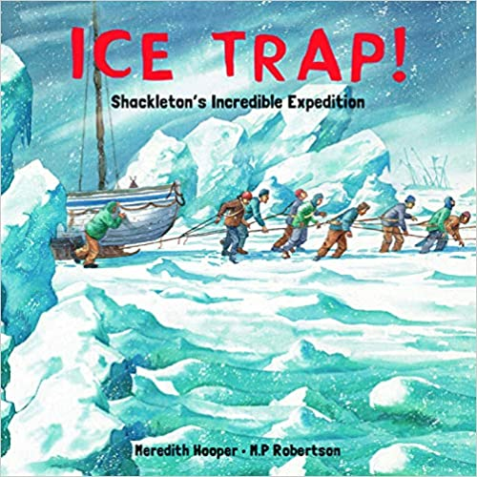 | Ice Trap by Meredith Hooper  In August 1914, during the height of the heroic age of Antarctic exploration, Sir Ernest Shackleton set off from England with a team of explorers to walk across the Antarctic and study the icy depths of this new and forbidding continent. Sailing through some of the most perilous seas, the Endurance becomes trapped in the deadly pack ice of the Weddell sea. When the Endurance is eventually crushed between the vast bulk of two floating icebergs, the men are forced to abandon ship and make the dangerous journey across the crushing sea in lifeboats. They reach relative safety on the uninhabited Elephant Island, but an even greater peril faces Shackleton and five other members of the crew.
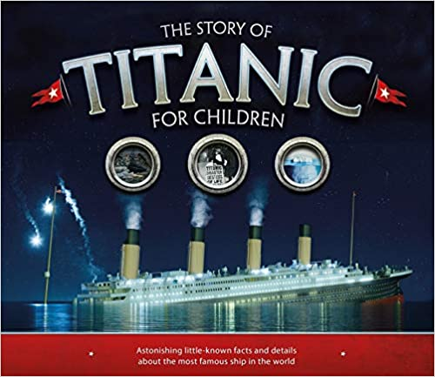 | The Story of the Titanic by Joe Fullman  Over one hundred years on, the captivating story of the Titanic has lost none of its appeal. This stunning book explores real-life stories and little known facts that will absorb young readers. Beautiful images and bite-sized information bring the Titanic to life, from its construction to the victims and survivors after its tragic sinking. Filled with amazing facts and details giving insights into the 'unsinkable' ship, The Story of the Titanic for Children will satisfy even the most curious minds.

